Flight Application (FRONTEND)
Kunal Garg
- Login
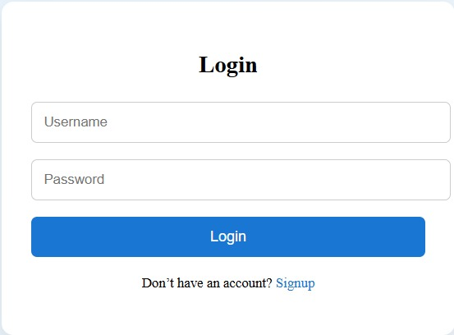
Validations :
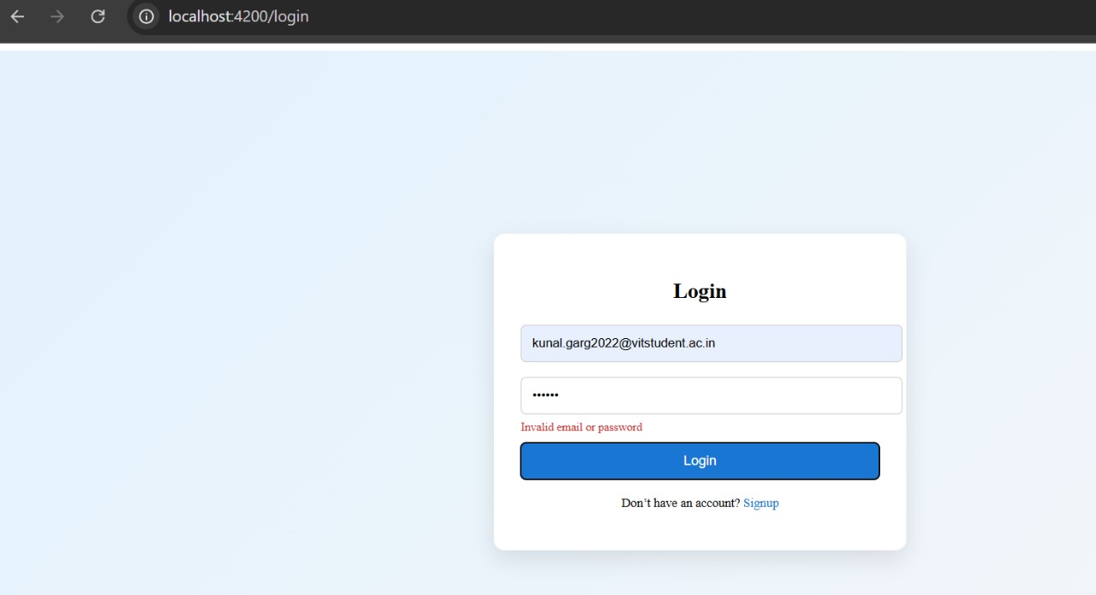

- Register
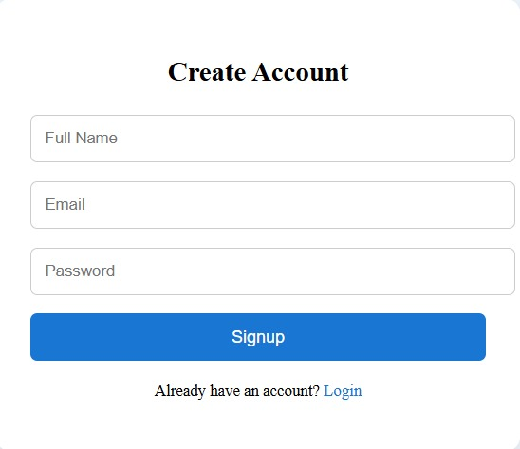
Validations :
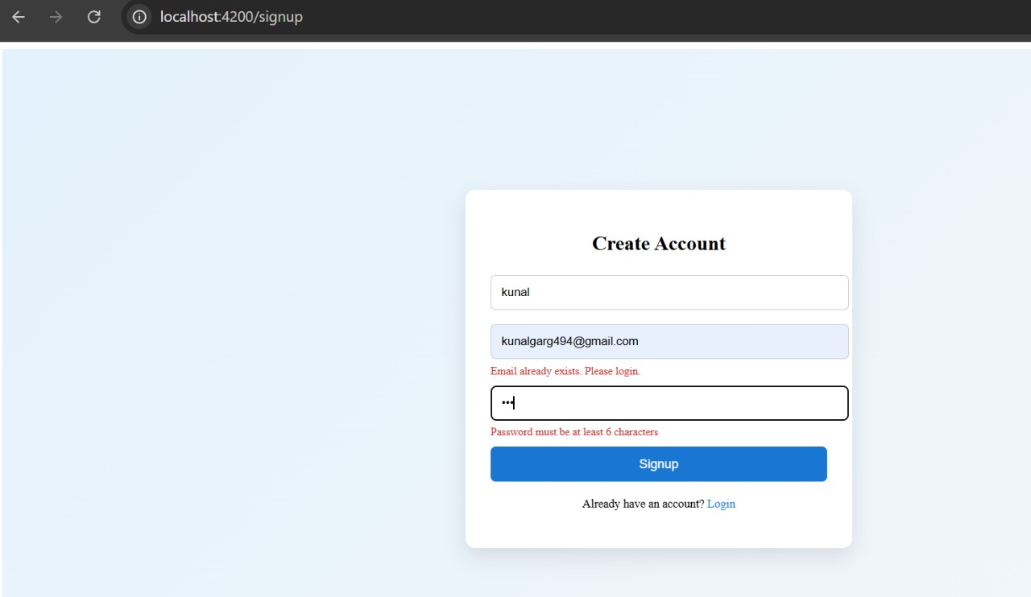

Implemented using both Dummy data and also integrated Backend in the project
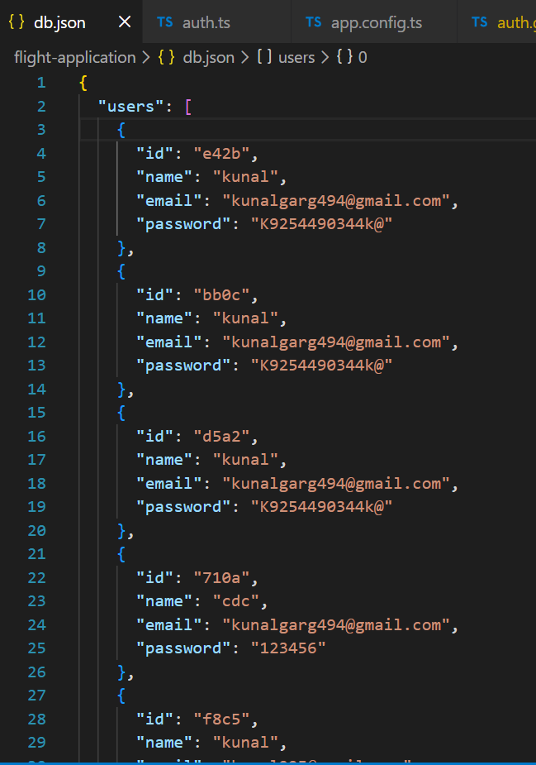
This is db.json that I first tested after this I tried it to connect with backend and now that is also working fine .
This is how in database data is getting stored through backend :
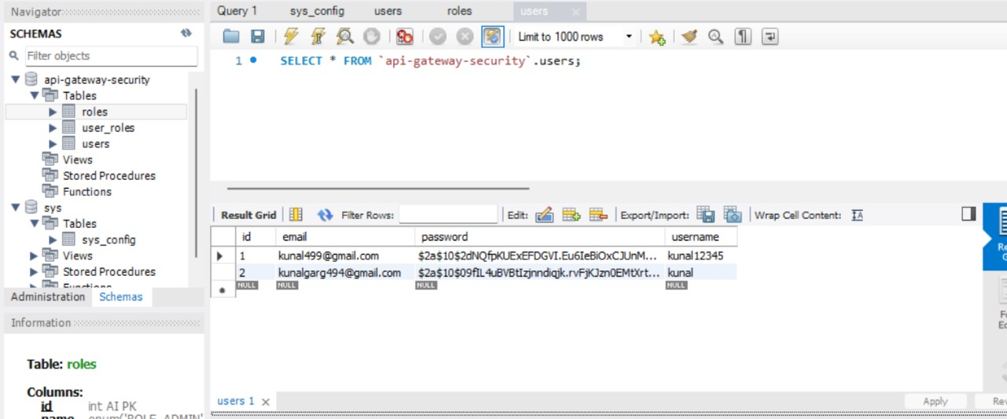
- Search Functionality
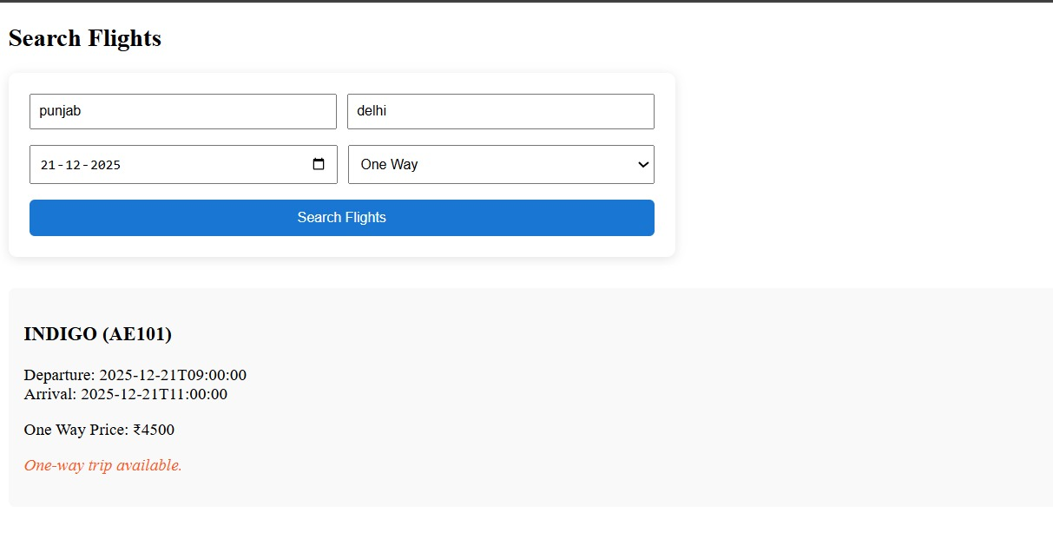

Backend project repository :

https://github.com/Kunalgarg92/microservice_implemented_docker

Frontend project repository :

https://github.com/Kunalgarg92/frontend_flight_service

